**SSW 567 - Assignment 1**

**Group 5**

Miguel Camacho

Ed Chang

Harmony Sullivan

**Assignment Description**

1. To get a set of tools up that your team can use throughout the course.
2. To create an initial program to be used in later assignments.
   1. Requirements: “A program reads three numbers. The three numbers represent the lengths of the sides of a triangle. The program prints a message that states whether the triangle is scalene, isosceles, or equilateral, and whether it is a right triangle as well.”
3. To learn how to write up assignment and turn them in.
4. To get to know your teammates and start figuring out how to work together.

**Summary of Results**

The team has agreed to use Github and Tortoisegit for code collaboration. Each team member has coded their own triangle program and has submit the code to the teams repository for other members to view, compare, and critique. See screenshots below for sanity checks. Group 5 will use Google Docs to write all collaborative assignments so each member can work on the assignment independently or work the assignment as a team. Communication between the team will be facilitated through Canvas and group meetings over Google Hangouts. Time will be coordinated and agreed upon with the understanding that members of the team live in different time zones. See screenshots below for group collaboration.

**Lessons Learned**

Google Hangouts works well for the team and is easy to use. The team attempted to use Google code for our repository, but was unsure how to set up and utilize it correctly. Github was used instead because prior use and experience. Currently some team members use Eclipse IDE for code creation and others use Netbeans. The team should consider agreeing on using only one type of IDE, but will continue to work with the understanding that code should work in either environment.

**Honor Pledge**

We pledge on our honor that we have not given or received any unauthorized assistance on this assignment/examination. We further pledge that we have not copied any material from a book, article, the Internet or any other source except where I have expressly cited the source.

**Sanity checks for code**

Enter 3, 3, 3 → Equilateral Triangle

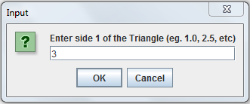

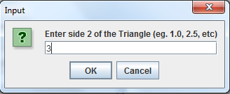

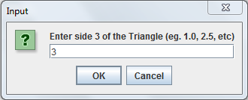

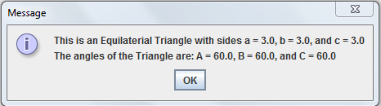

Enter 2, 2, 1 → Isosceles triangle

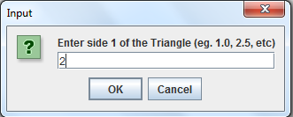

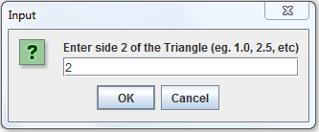

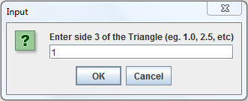

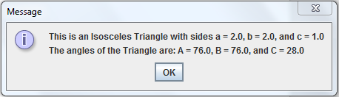

Enter 3, 4, 5 → Scalene and right-angle triangle

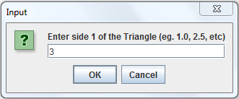

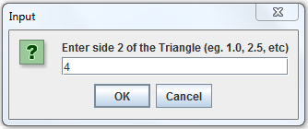

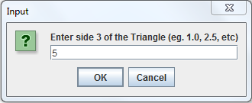

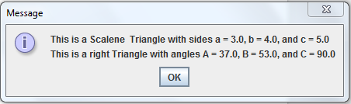

**Group Collaboration 1**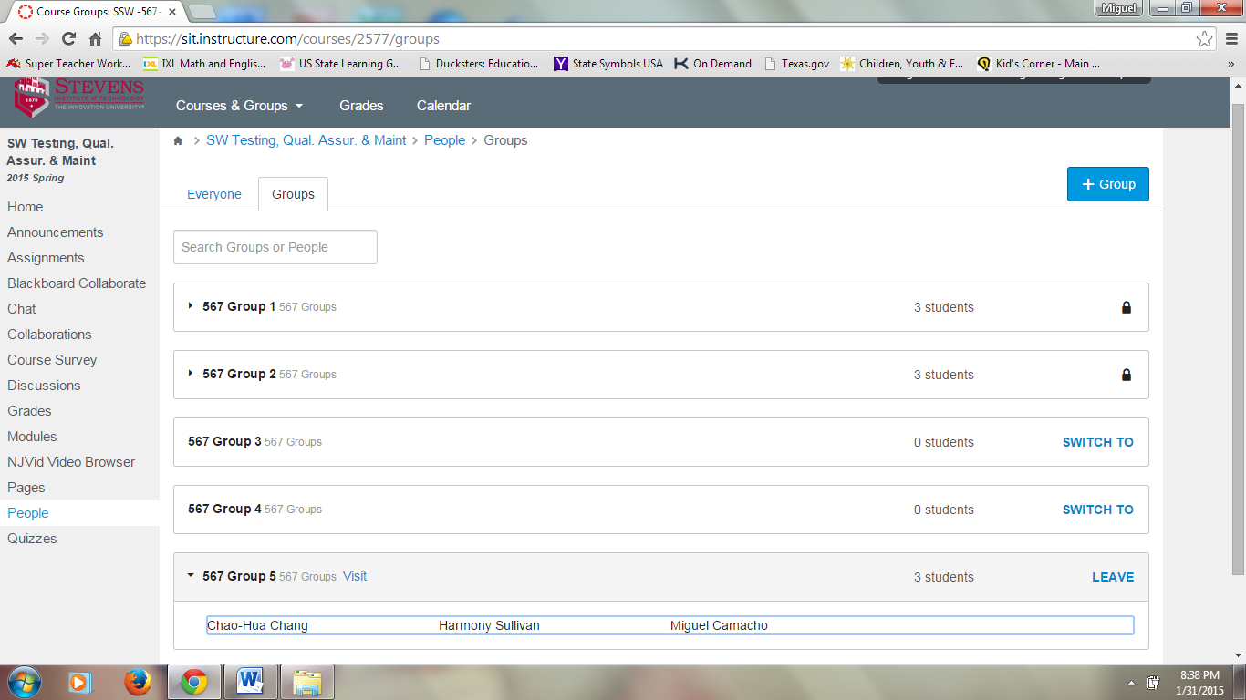

**Group 5 Canvas Screenshot**

**Group Collaboration 2**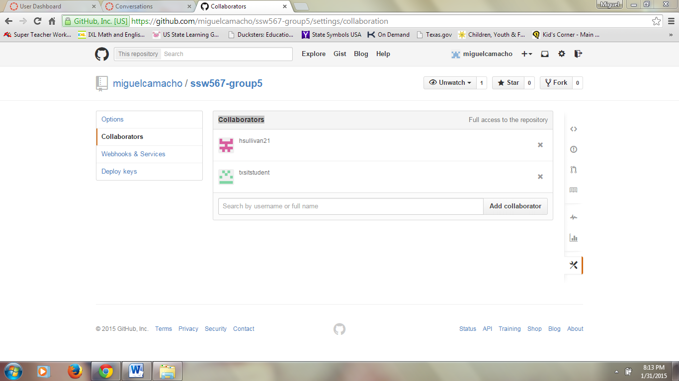

**Group 5 Github Collaborators Screenshot**

**Group Collaboration 3**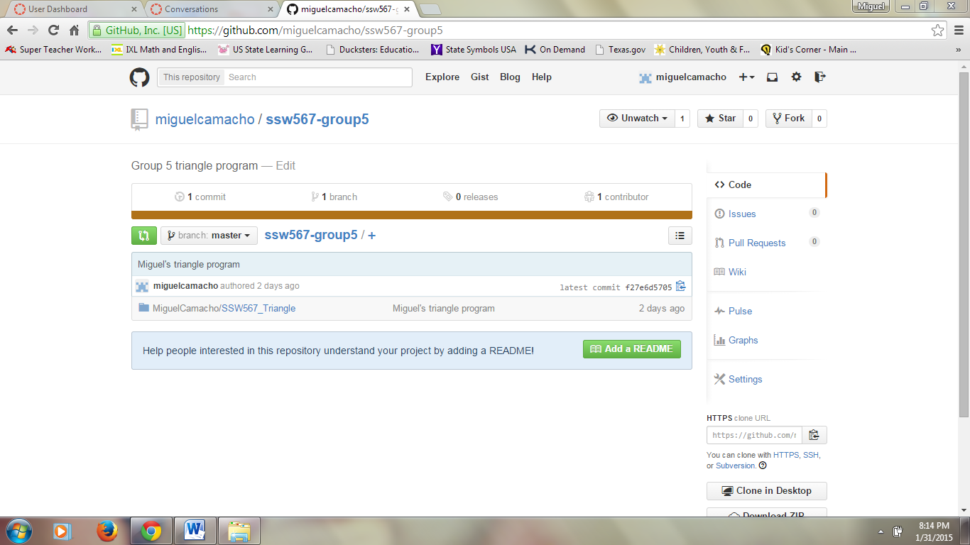

**Group 5 Github Repository**

**Group Collaboration 4**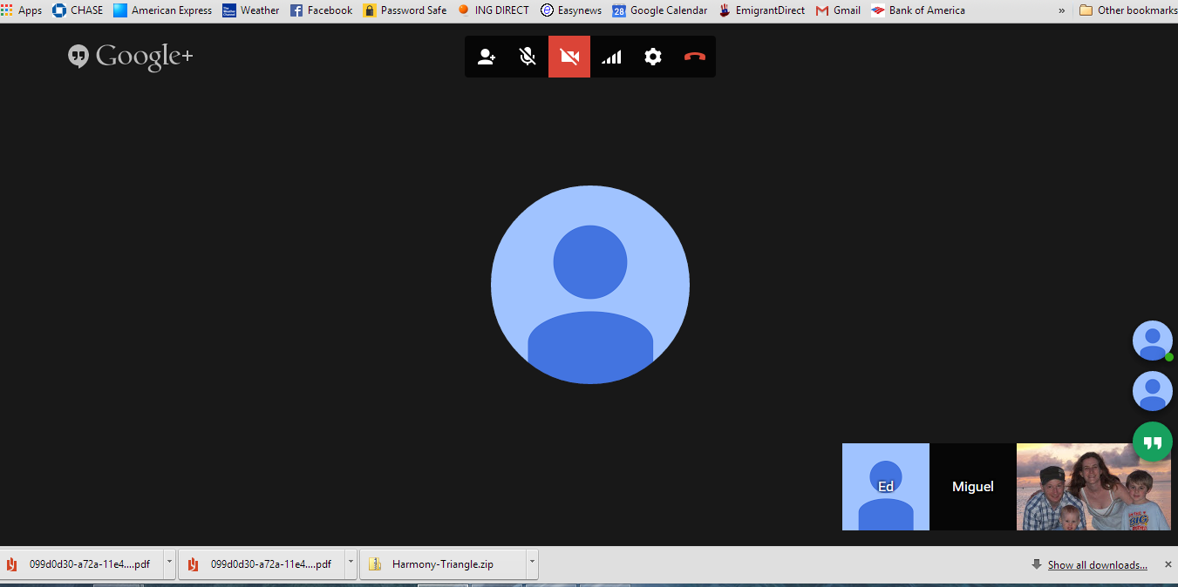

**Group 5 Google Hangout**

**Group Collaboration 5**

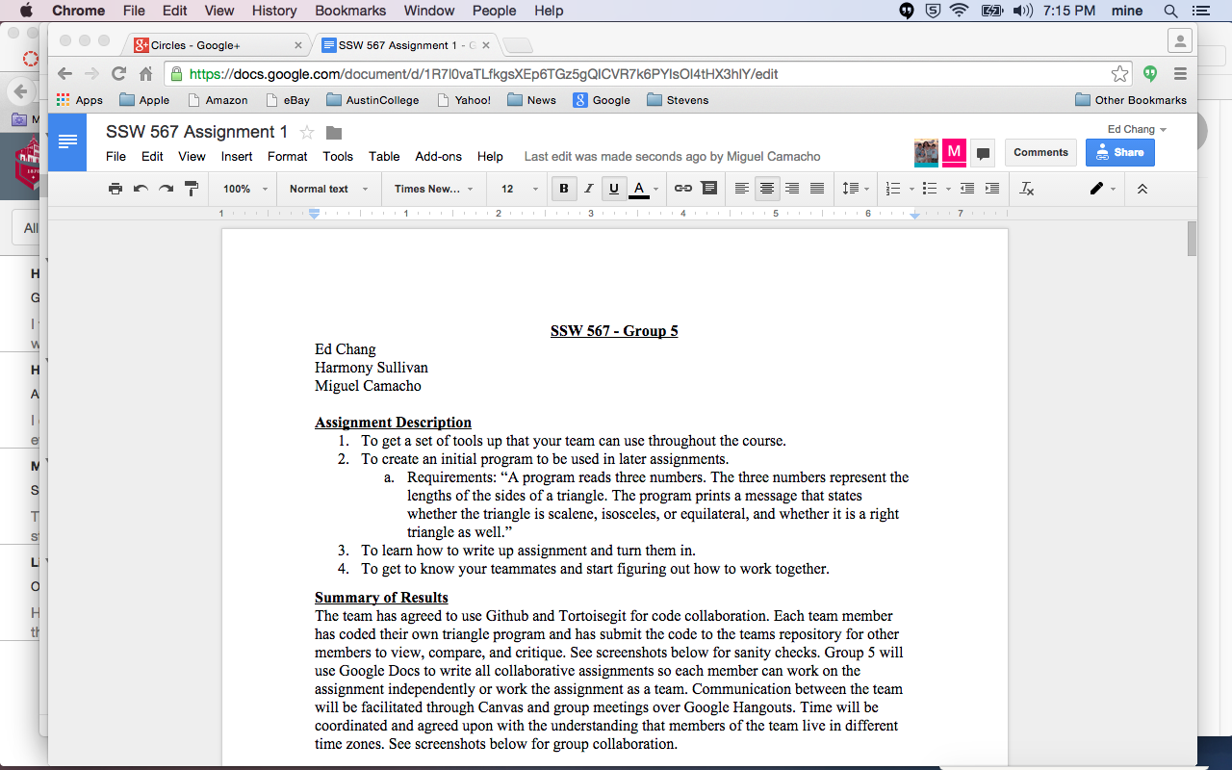

**Group 5 Google Docs**